Self-Screening Questionnaire
The safety of our workers, customers and visitors remains our primary concern. As the COVID-19 outbreak continues to evolve and spread globally, we are monitoring the situation closely and will periodically update our guidance on current recommendations from the public health and other government authorities.
To help prevent the spread of COVID-19 and reduce the potential risk of exposure to our workers and visitors, we are conducting a simple screening questionnaire. Your participation is important to help us take precautionary measures to protect you and everyone in the workplace.
Full Name:
Email & Phone:
Group/Company:

Do you have any of the following?
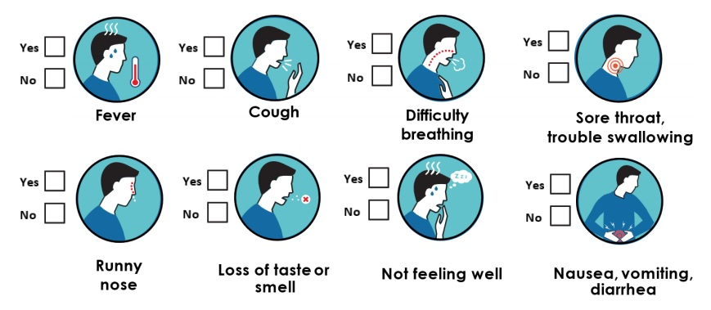
Have you been in close contact with someone who is sick or has been confirmed with COVID-19 in the past 14 days? | Yes | No
Have you returned from travel outside Canada in the past 14 days? | Yes | No

Declaration:
I herby confirm that the information provided is accurate, correct and complete and that the responses submitted within this form are genuine.

